**JSON Path Generator**

**JSON Path Generator** is a Web Application that accepts a JSON file containing Class Names and the Class Name identified after inspecting an element in the Browser. The Application then searches the Class Names file for the identified Class Name and returns the JSON Path for that Class Name.

**Advantages:**

* Reduces the time of manually traversing the JSON file hierarchy to generate the path of a Class Name.
* Reduces the time of manually typing the then recognized path in the function.

**Dis-Advantages:**

* Accepts only one Class Name at a time.

**Example:**

Time consumed to find the path of a Class Name **mpageui-ComponentHeader-lookbackSubheader** and Call it in the function.

**Manually:** 1 minute 31 seconds

**JSON Path Generator:** 25 seconds

**Points to Remember:**

* Enter only the Class Name.
* Make sure that there are no spaces before and after the Class Name.

**Path to Install the Application:**

<https://github.cerner.com/wd050729/mPage-JSON-Path-Generator>

**How to Use:**

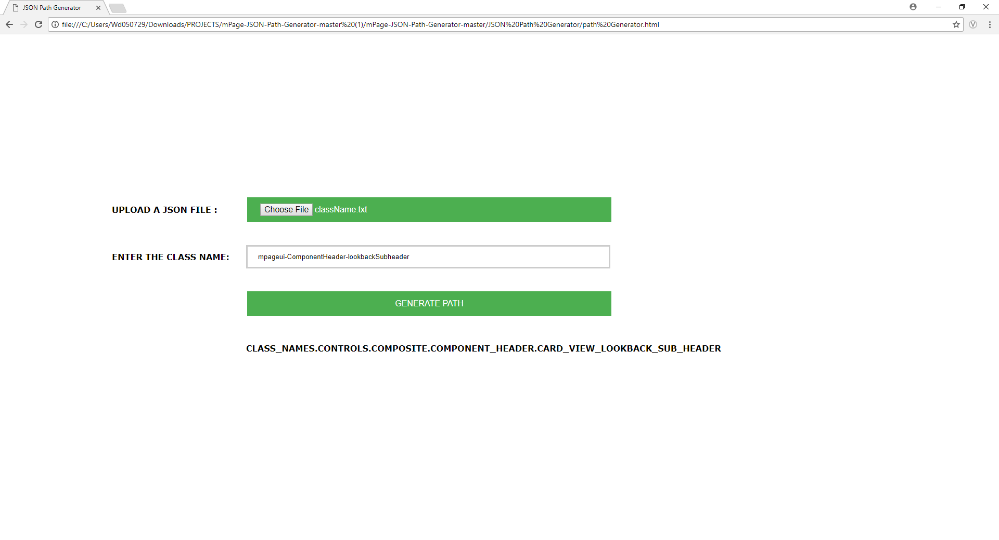

1. Clone the repository to local machine from the above link.
2. Unzip/Extract the files.
3. Open the Path Generator html file.
4. Click on the Choose File button and import the Class Name file.
5. Enter the Class Name to which the Path is required.
6. Click on the GENERATE PATH button.
7. Copy the text generated below and paste it in your function.

**Successor:**

**Variable Path Generator.**